This document is the deployment document of the WeTech Application and is used to deploy WeThech to a LINUX server.

1. Server Requirement
   1. Configuration requirements: CentOS Linux release 7.8.2003 (Core) server (64bit), 8G or above RAM space, 1G or above hard disk storage space.
   2. All subsequent operations require root privileges. If you do not have this permission, please contact your IT department to obtain it. If you have root privileges, use the sudo su command to enter the highest privilege mode (you may be asked to enter your password after the "sudo su" command is executed). After success, you will see your cli interface as follows: 
2. Install Java environment

Our software is developed based on Java, so a JAVA17 operating environment needs to be installed.

* 1. Download and install Java: For more information, please visit <https://www.java.com/en/download/help/download_options.html> .
  2. Edit the configuration file and configure Java system variables: edit your system environment profile (Generally, the profile is /etc/profile in CentOS).

export JAVA_HOME=/root/packages/java1.8

export JRE_HOME=${JAVA_HOME}/jre

export CLASSPATH=.:${JAVA_HOME}/lib:${JRE_HOME}/lib

export PATH=${JAVA_HOME}/bin:$PATH

The effect after operation is as follows:

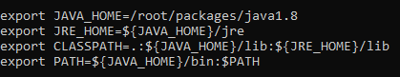

* 1. Enable the setting

source /etc/profile

* 1. Verify whether the configuration is successful

java –version

If you see the following interface, it means you have successfully installed JAVA.



1. Install Maven environment

Our project is based on maven, so we need to install Apache Maven.

* 1. Download and Install Maven

For more information, please visit:

https://maven.apache.org/install.html

1. Deploy the Server

At this point, you should have installed all the environments required. Using the following command to compile the project:

mvn clean install -Dmaven.test.skip=true

After that, you should see the following output:

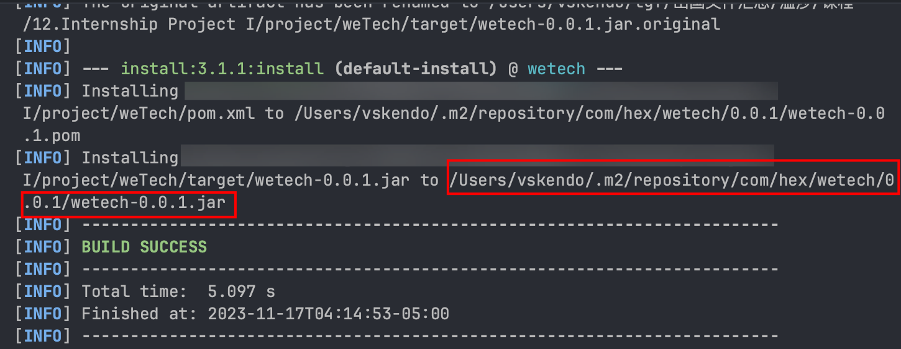

The path of the package is shown in the output.

Running it: java -jar ./wetech-0.0.1.jar

The server is successfully running now.

1. Editting and Maintaining

All the Java source code are under:

weTech/src/main/java/com/hex/wetech.

The entery point is WetechApplication.java

* 1. Interceptor and Controller

All the source code of controller (Interceptor) is under controller package. This is for processing the request.

* 1. Core and Configuration

All the source code of configuration is under core/common/config. Unless you familiar with SpringBoot or know what you are doing, I not suggest you to edit them.

* 1. Tomcat and Front end

The front-end code is under /webapp, and the static resources is under /resources. The running of front-end JSP code is supported by Apache Tomcat.